NATIONAL INSTITUTE OF TECHNOLOGY KARNATAKA SURATHKAL

DEPARTMENT OF INFORMATION TECHNOLOGY

IT 301 Parallel Computing LAB 2

19th August 2020

Faculty: Dr. Geetha V and Mrs. Tanmayee

-------------------------------------------------------------------------------------------------------------------------------

**Name:** Chinmayi C. Ramakrishna

**Roll No.:** 181IT113

**Program 1:**

**To understand and analyze shared clause in parallel directive.**

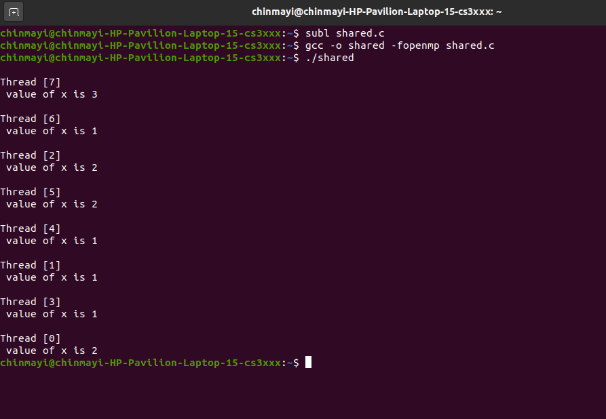

Value 1 is shared by three threads 1,4 and 6.

Value 2 is shared by three threads 0,2 and 5.

Value 3 is shared by thread 7.

**2. Program 2**

**Learn the concept of private (), firstprivate ()**

**private()**

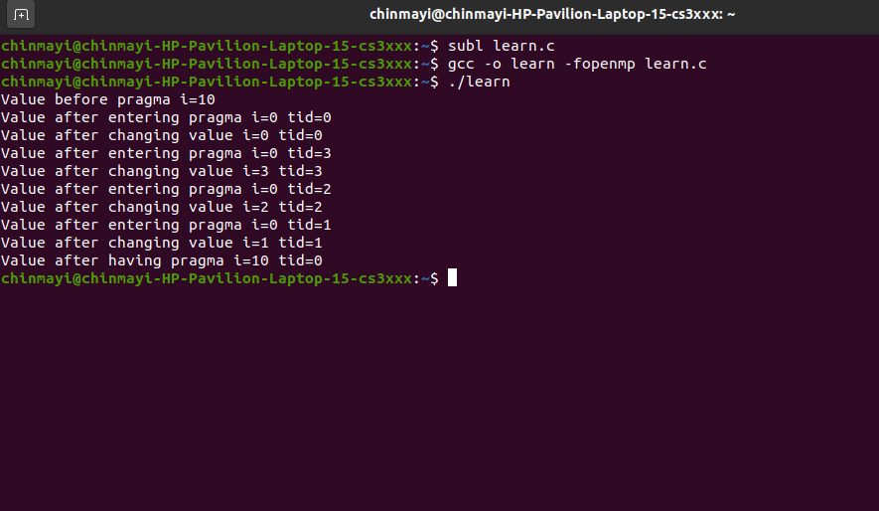

Each thread 0, 1, 2 and 3 has its own instance of variable i=0

**firstprivate()**

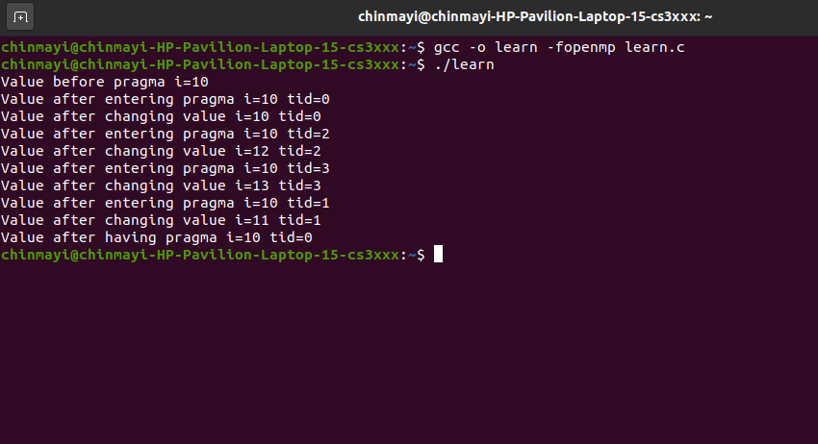

Every thread 0, 1, 2 and 3 has its own instance of the variable and the variable is initialized with the value of the variable. The threads 0, 1, 2 and 3 have i=10.

**3. Program 3**

**Learn the working of lastprivate () clause:**

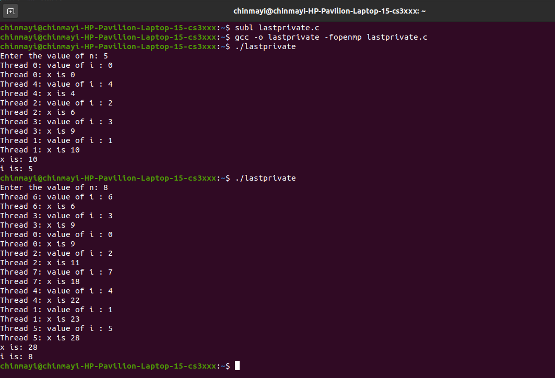

The value of x at the next iteration is i of the current iteration+ value of x at the previous iteration. The variable that is set equal to the private version of a particular thread executes the final iteration or the last section.

**4. Program 4**

**Demonstration of reduction clause in parallel directive.**

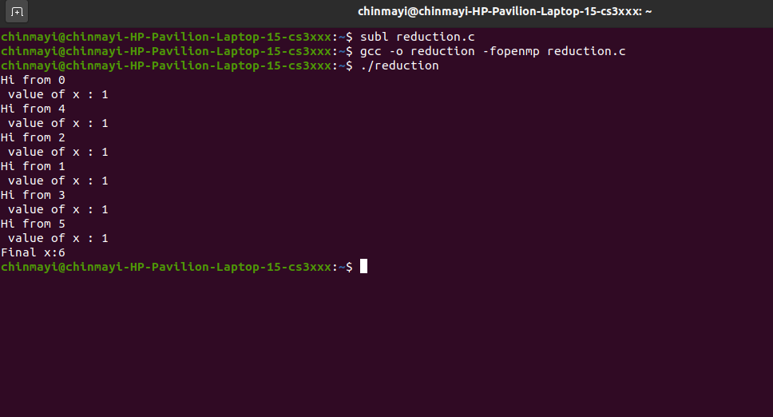

Reduction clause specifies one or more thread-private variables that are subject to a reduction operation at the end of the parallel region. + operator needs to be specified to perform the reduction.

**5. Programming exercise**

**1. Write a parallel program to calculate the sum of elements in an array.**

**Code:**

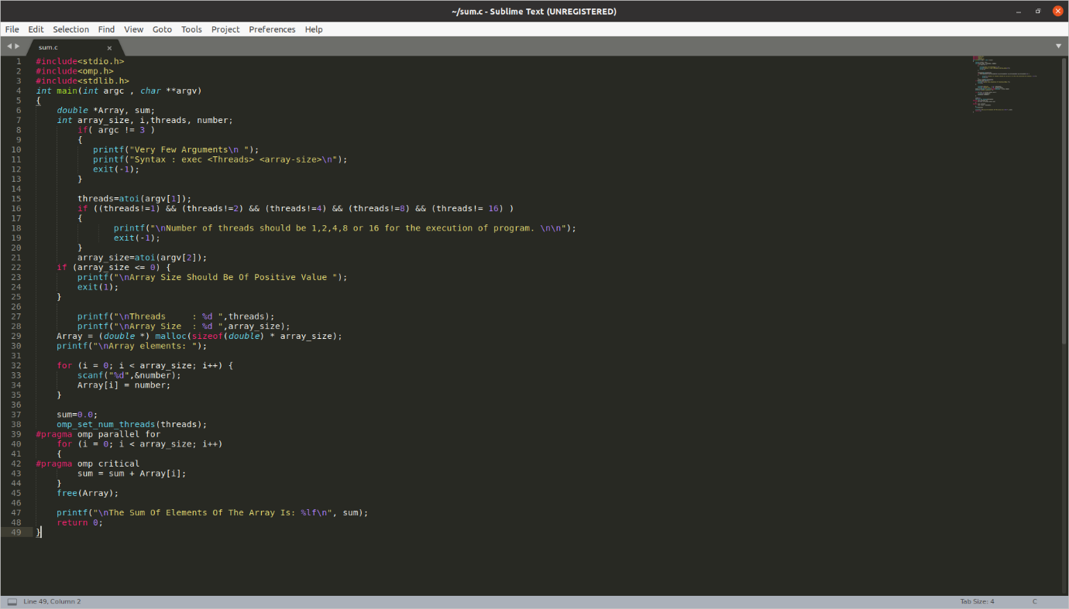

**Output:**

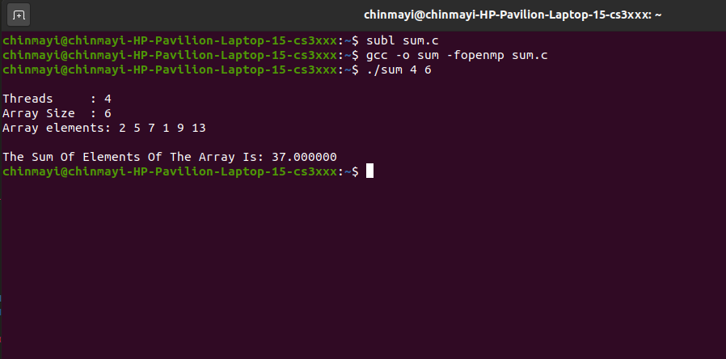

**2. Write a parallel program to calculate the a[i]=b[i]+c[i], for all elements in array b[] and c[].**

**Code:**

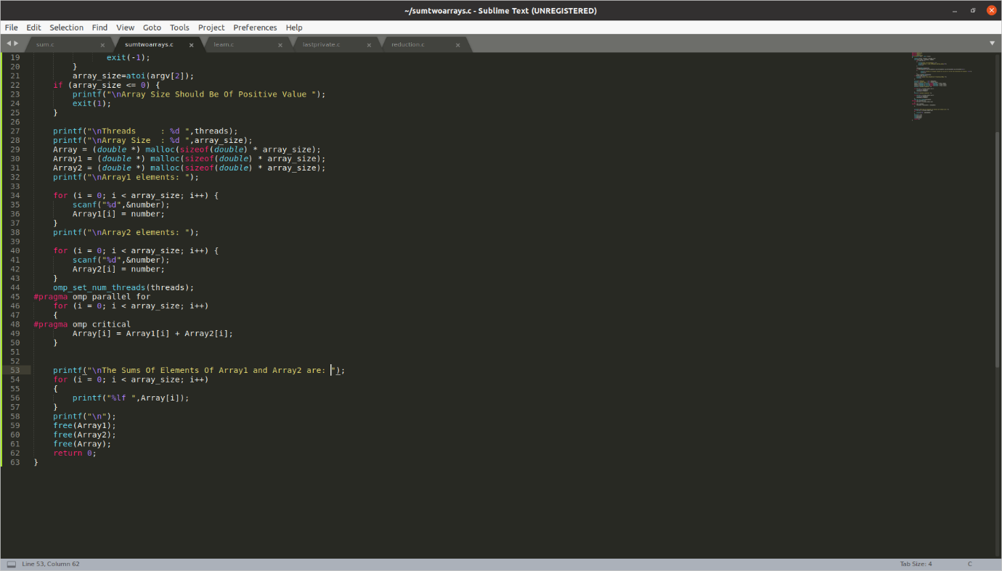

**Output:**

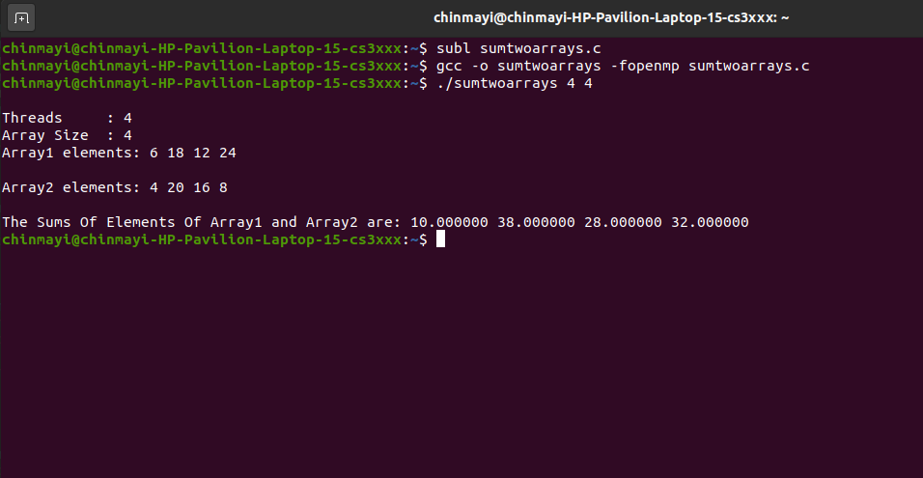

**3. Write a parallel program to find the largest among all elements in an array.**

**Code:**

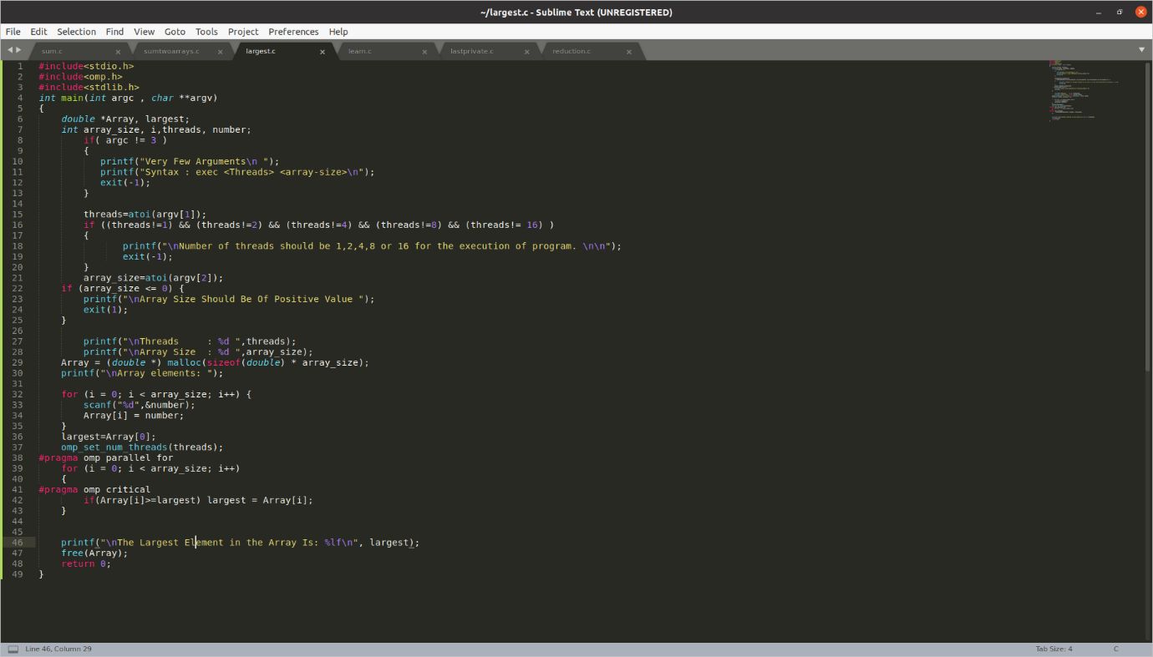

**Output:**

